RHBT CUSTODY DEFECTS: Companies Used (KFINTECH, CUSTODY TEST)
- Customer Master:
1a). After Uploading Bene Upload Showing as complete instead of pending with BOMBOAMBOMM showing in 301915 id(COMPANY: KFINTECH)
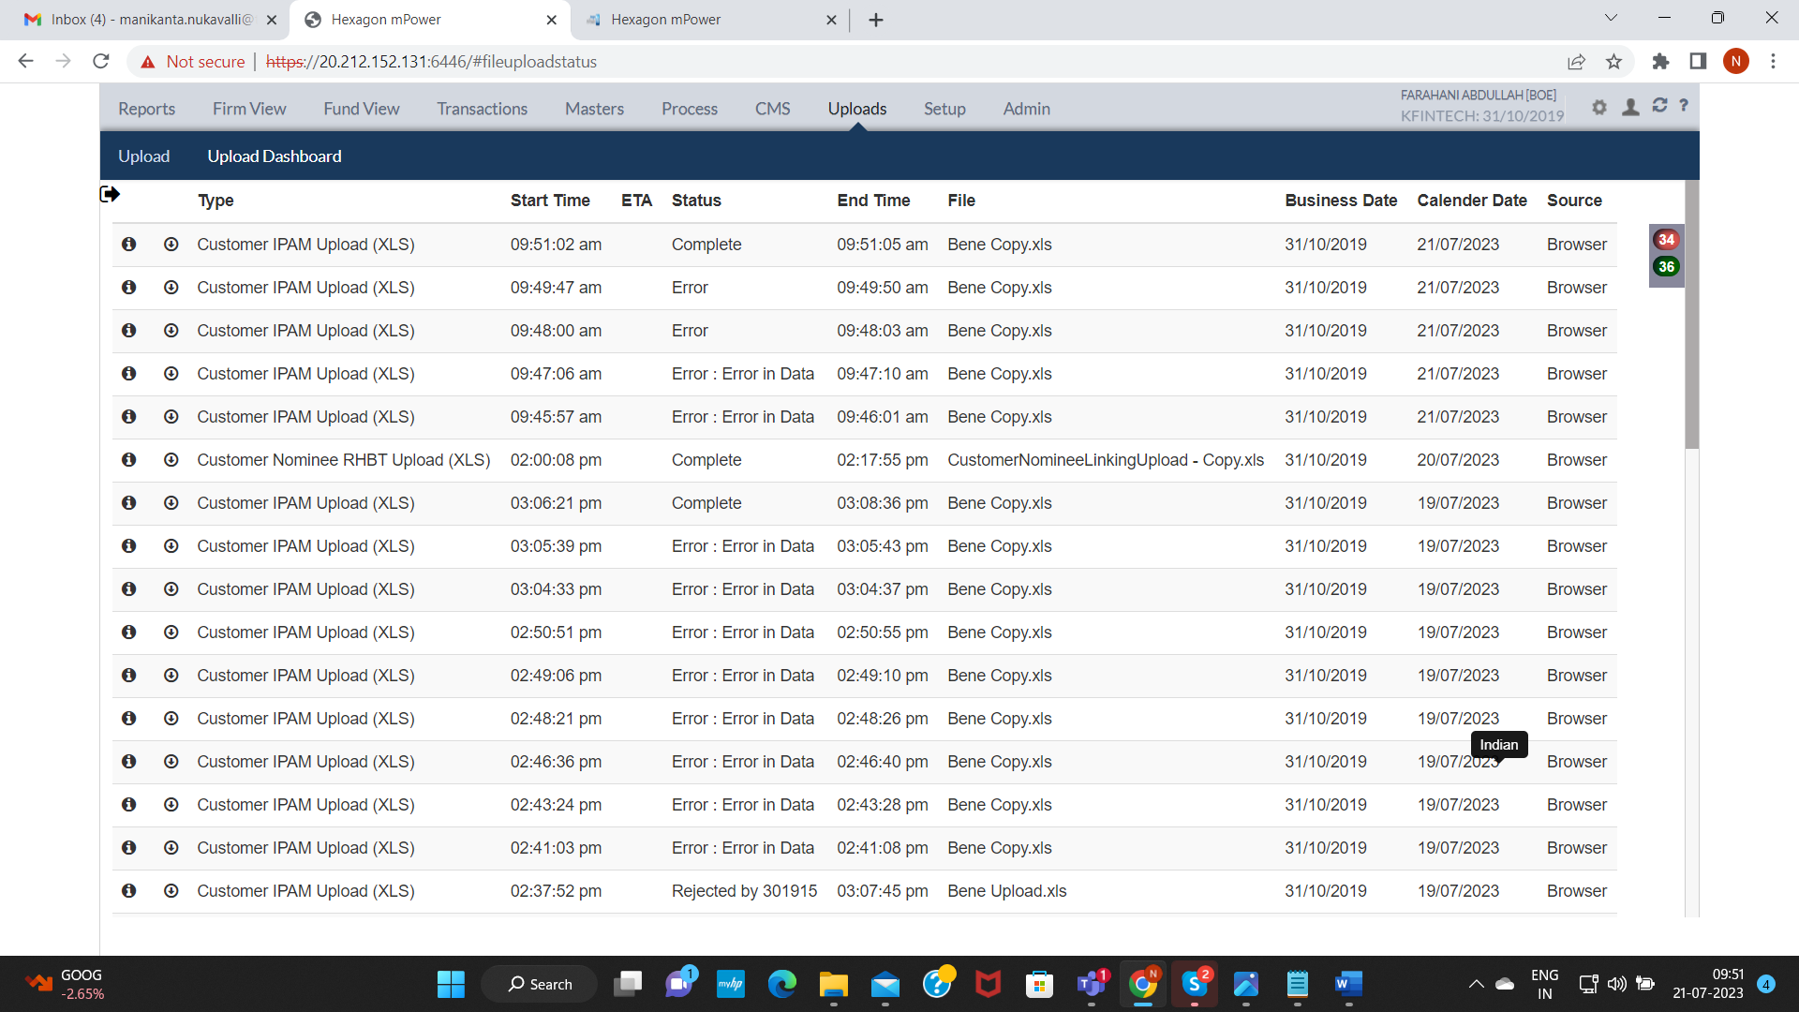

1b). Permanent Address Information was not Capturing in Permanent Address Fields in Customer Master(CU) (COMPANY : KFINTECH)
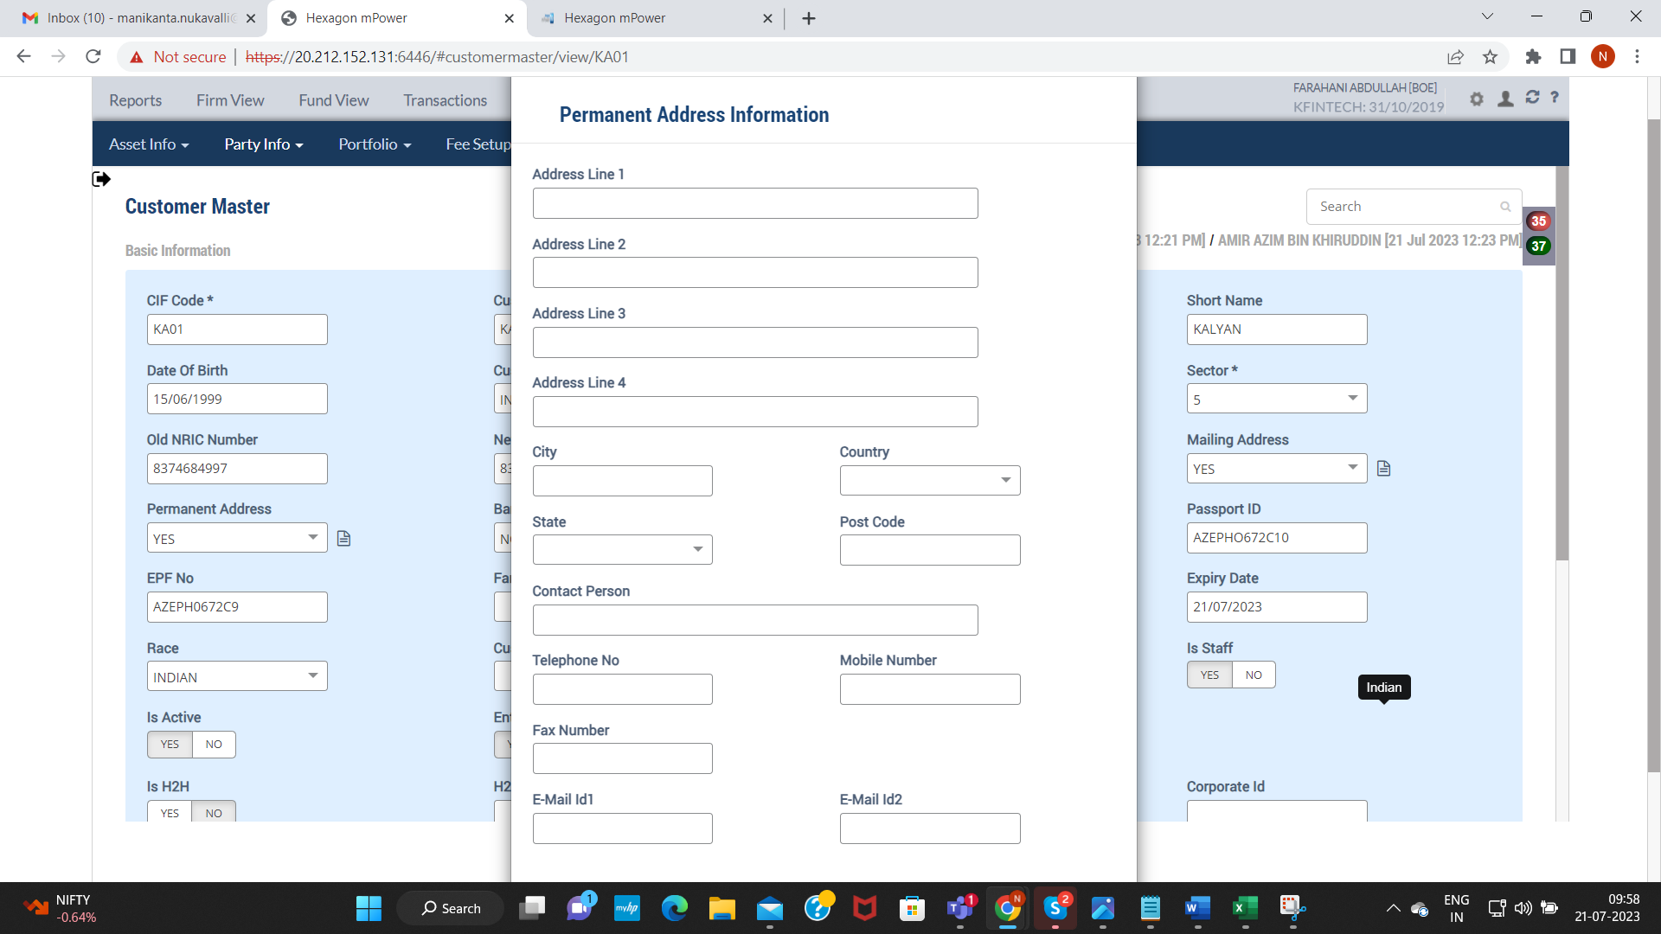

1c). Customer Group was not capturing in Customer Group Filed in customer Master(CU) (COMPANY: KFINTECH)
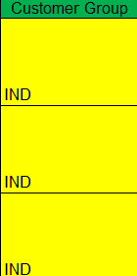

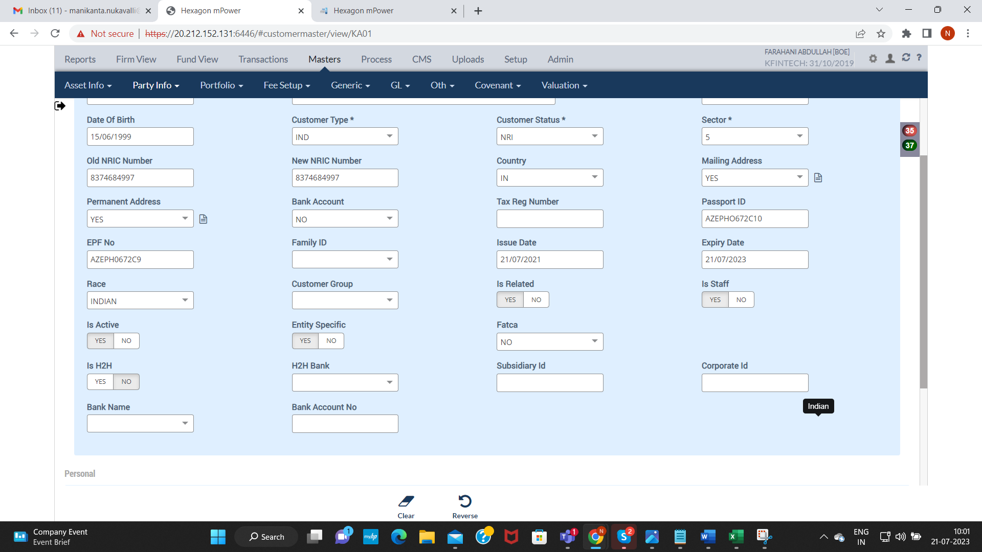

1d). Family ID not capturing in the Customer Master(CU) (COMPANY: KFINTECH)
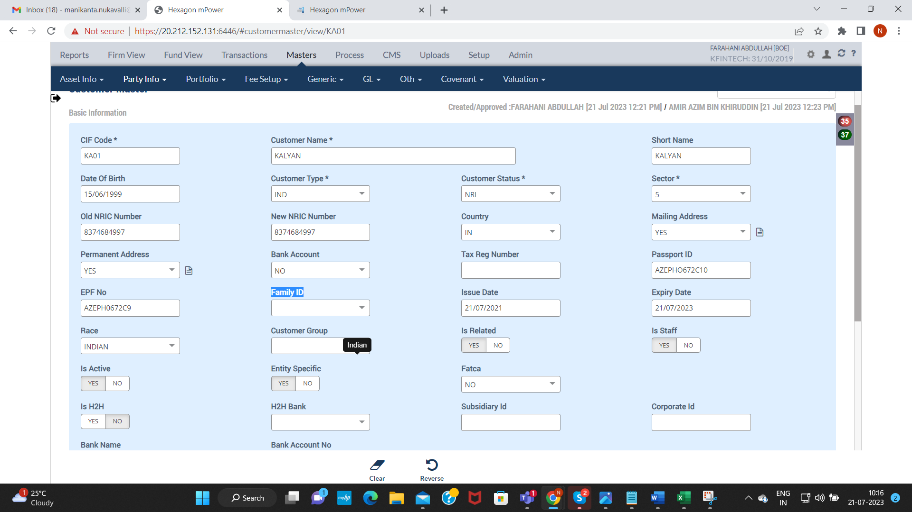

1e). Issue Date Should be Less than the Current Date but while Uploading Not showing any Error Message. (COMPANY: KFINTECH)

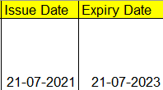
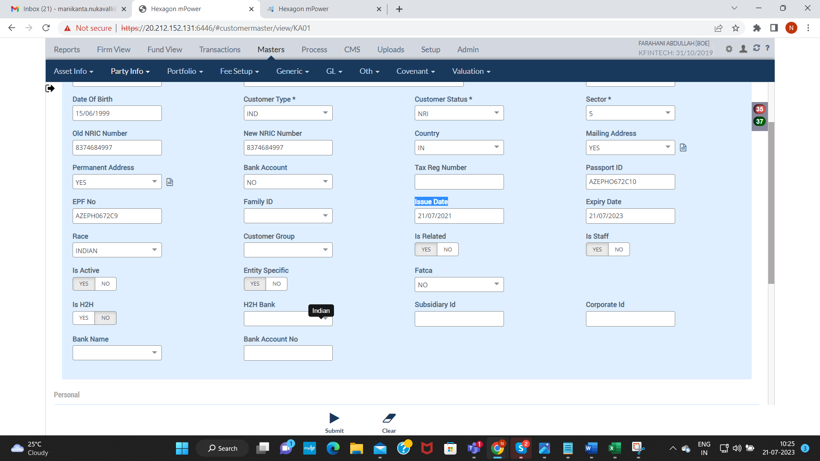

1f). In customer Master Country field is showing Error since this is not a mandatory filed. Either Filed should make mandatory or Pop up Should not be shown(COMPANY: KFINTECH)

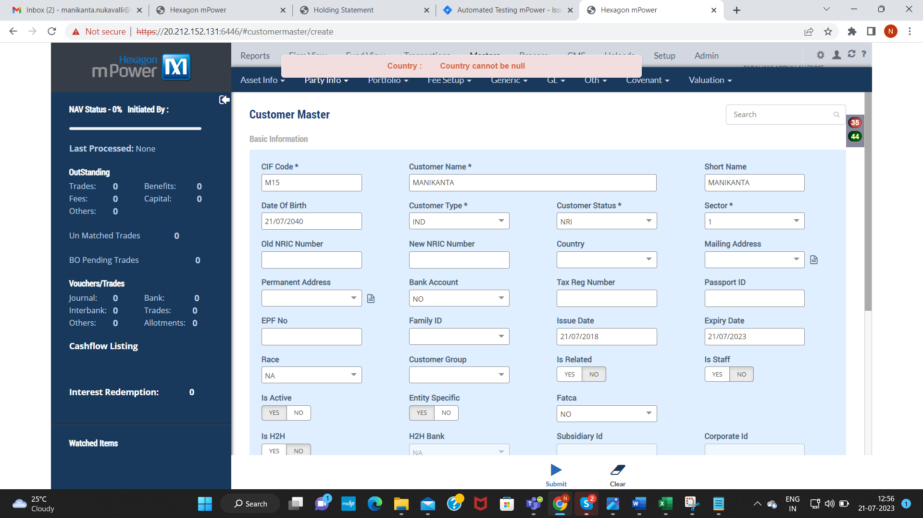

1g). Customer Master Form is getting Approved without DOB when we give Customer Type as IND – “INDIVIDUAL “ As DOB is Mandatory for Customer Type “IND”(COMPANY: KFINTECH)
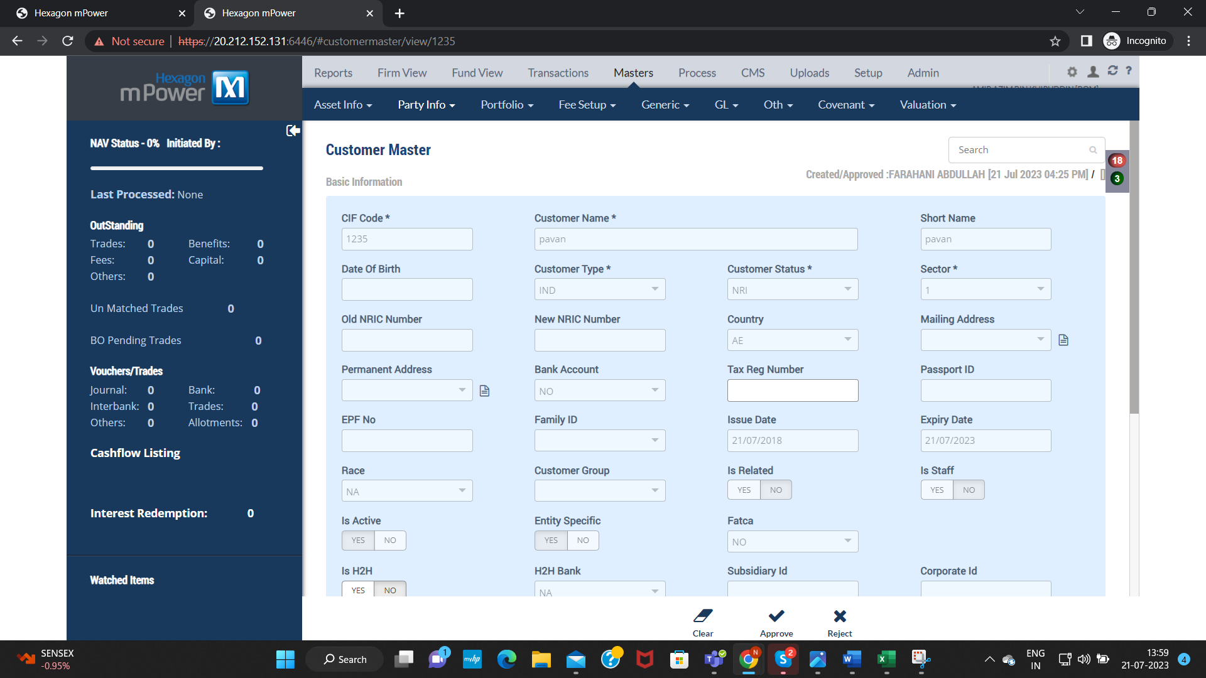

- Beneficiary Upload:
2a). Residential Status capturing Wrongly in Residential status Field in Other Party Master.(BN)(COMPANY: KFINTECH)

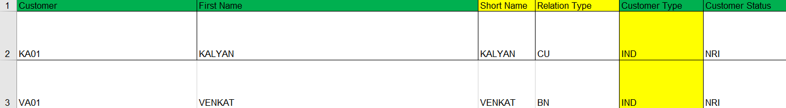
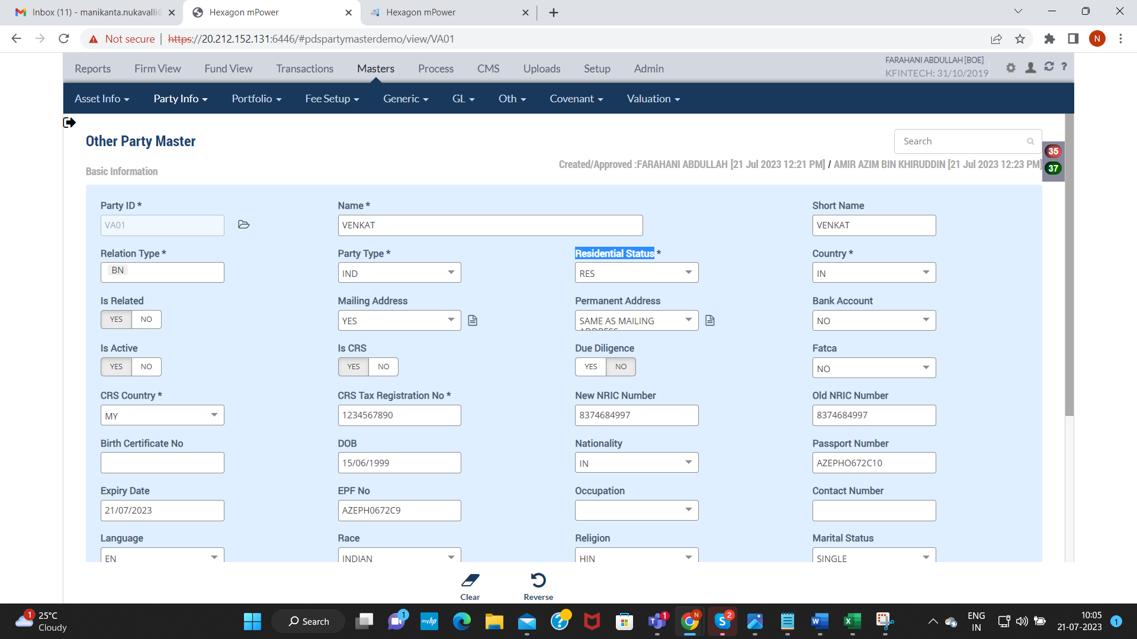

2b). Permanent Address Information was not Capturing in Permanent Address Fields in Other Party Master for Beneficiary. )(COMPANY: KFINTECH)
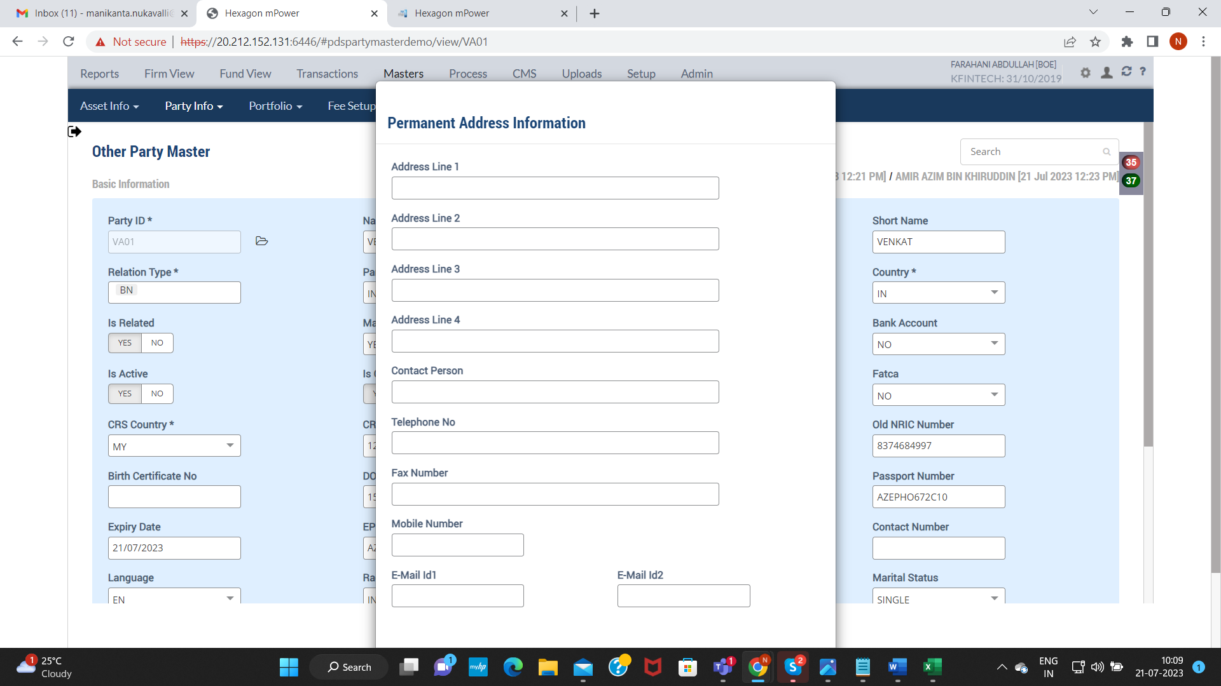

- Agent Upload:
3a). Residential Status capturing Wrongly in Residential status Field in Other Party Master. (COMPANY: KFINTECH)

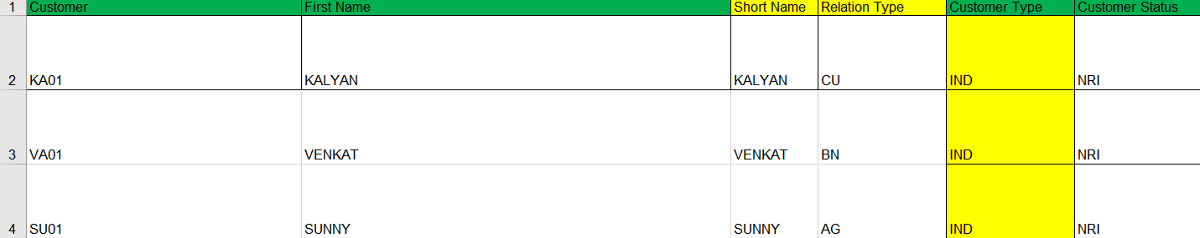

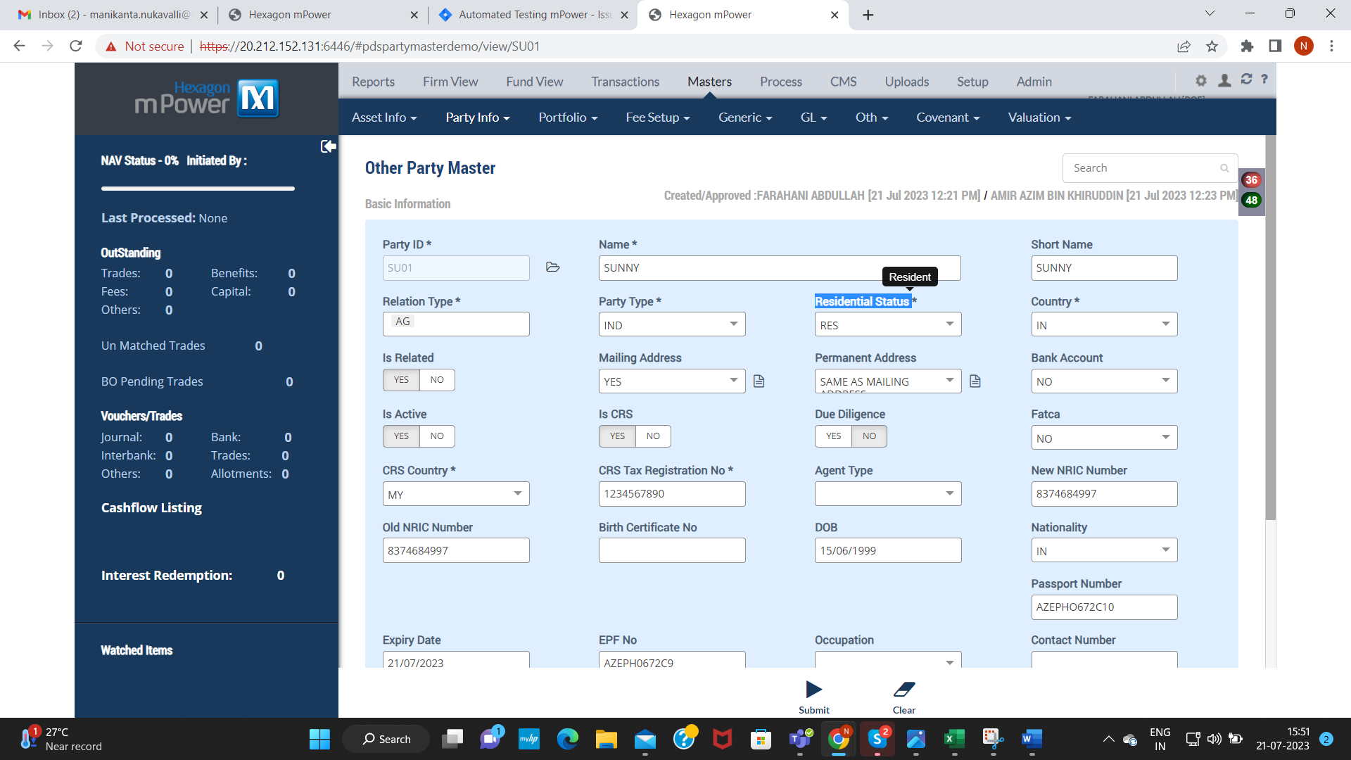

3b). Permanent Address Information was not Capturing in Permanent Address Fields in Other Party Master for Agent. (COMPANY: KFINTECH)
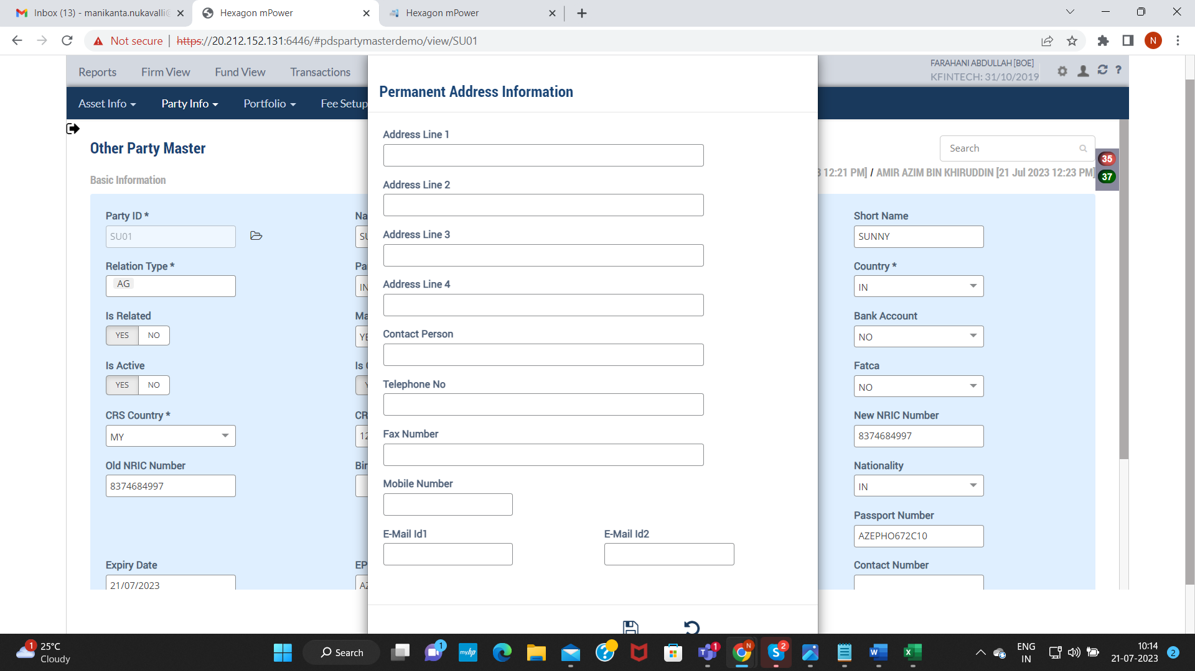

- Portfolio Holding:

4a). After Uploading Portfolio Holding Showing as Complete instead of pending with BOMBOAMBOMM and not reflecting in 301915 ID
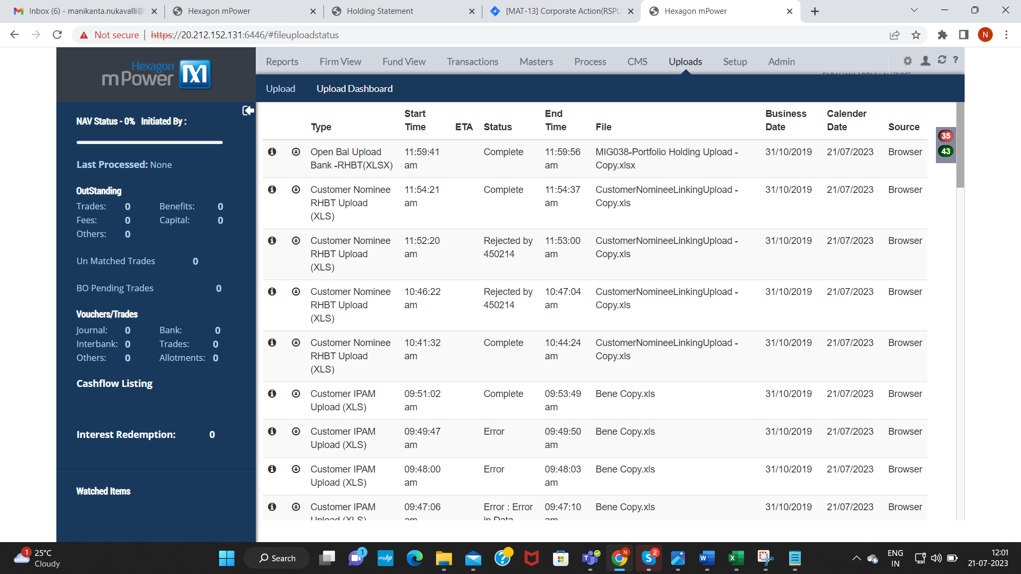

- Beneficiary Holdings:
5a). Uploading Bene Holding Showing as Complete instead of pending with BOMBOAMBOMM and not reflecting in 301915 id(Company: KFINTECH)
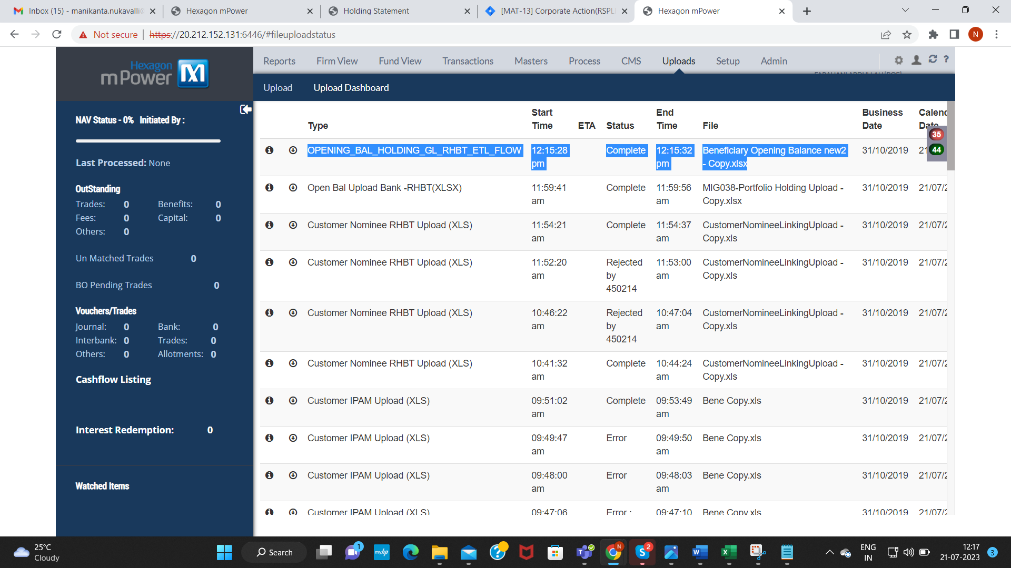

5b). After Uploading Bene Holding details are coming in Holding Desk but not Reflecting in Holding Desk Dtl (Company: KFINTECH)
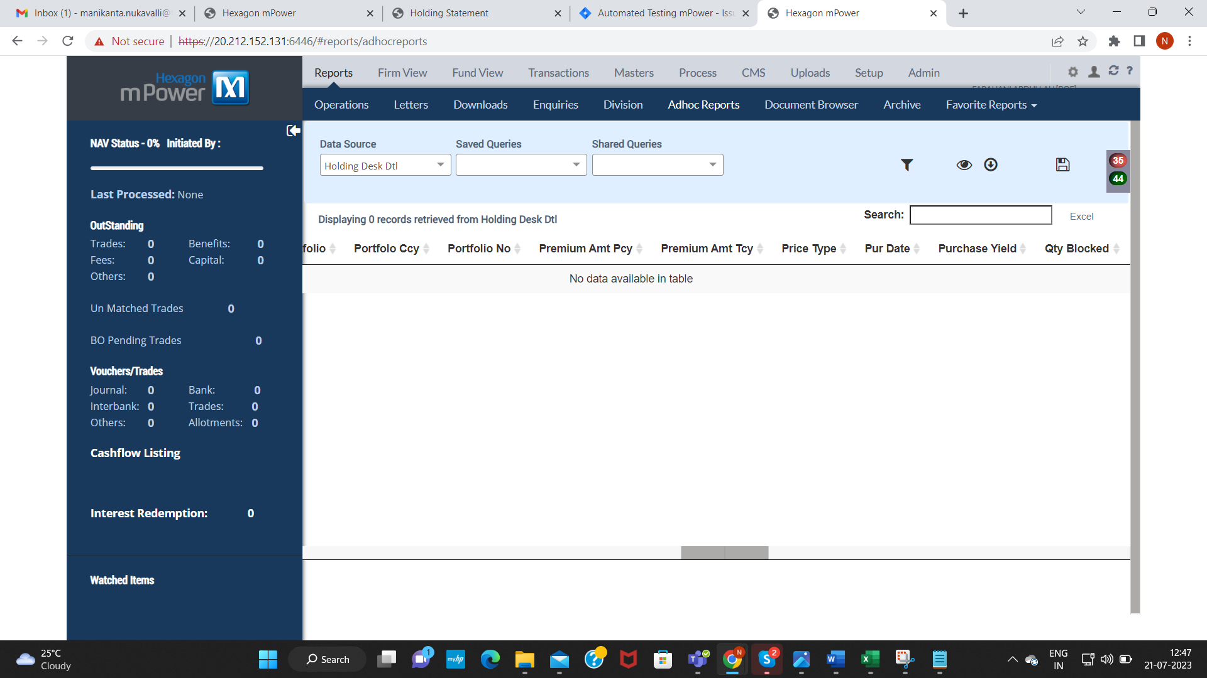

6.Product Master:
6a.After submitting Product Master from Maker ID, it is not alerting in Checker ID to approve(Company : CUSTODY TEST)

Step 1: Submitted the Product Master Form
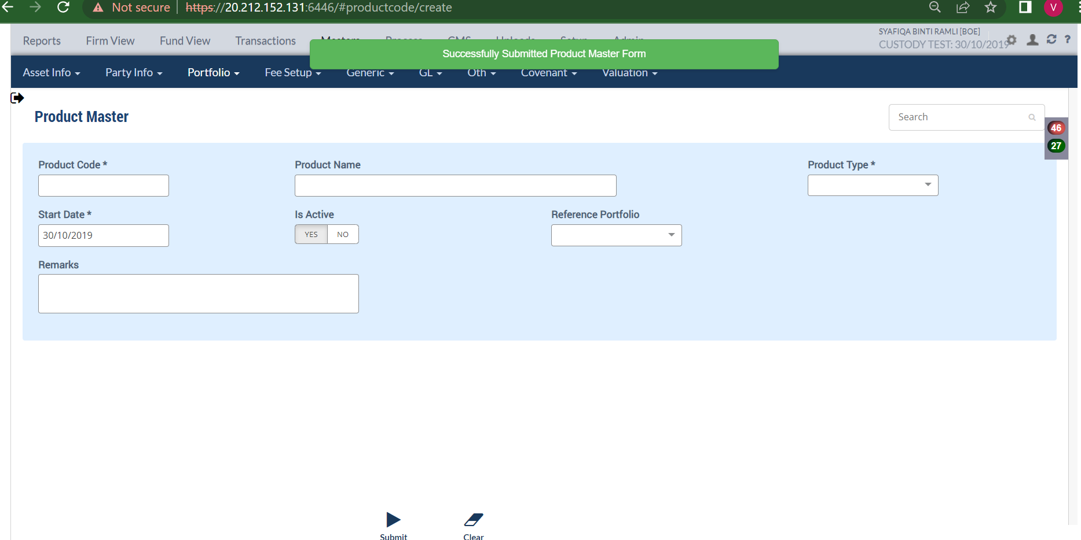

Step 2: Not alerting in Checker ID(301919) for approving the form.
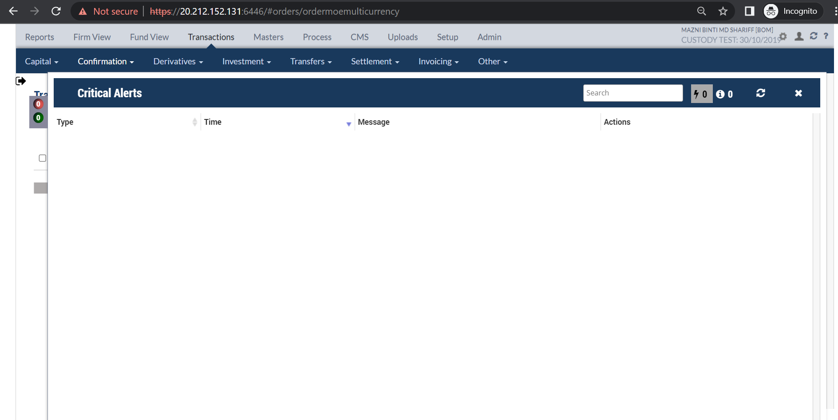

7.Customer Nominee Upload: (Company : CUSTODY TEST)
7a.After uploading Customer Nominee Excel file, alert going to only ‘BOM’ and not for ‘BOAM,BOMM’(Since it is H2H interface).
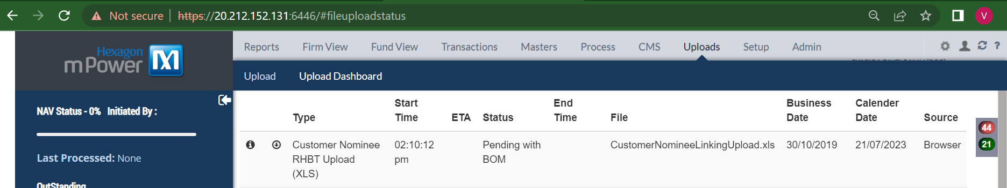

7b. Customer Nominee Excel file uploading successfully with same CDS Account No and Certificate No for multiple nominees. (Company : CUSTODY TEST)
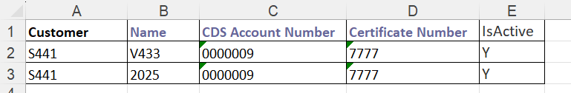

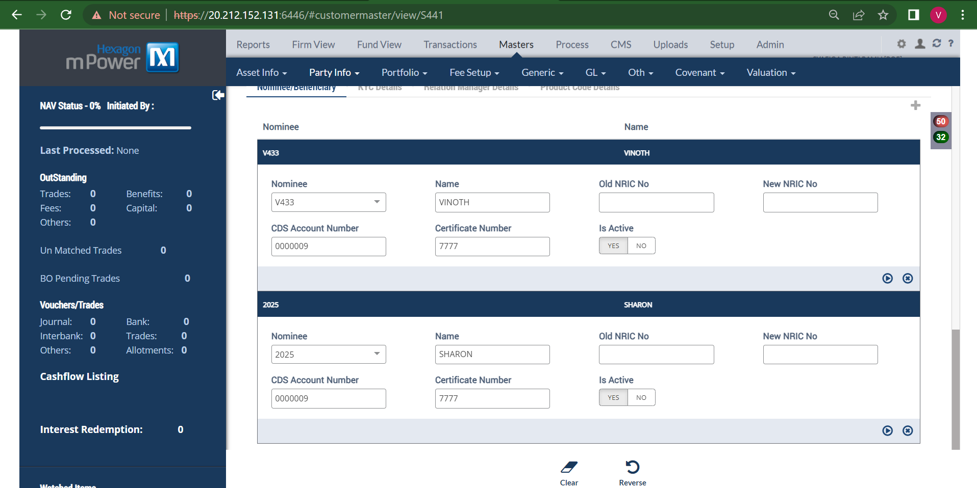

7c.While entering Manually Customer Nominee, it is accepting same CDS Account Number for multiple nominees. (Company : CUSTODY TEST)
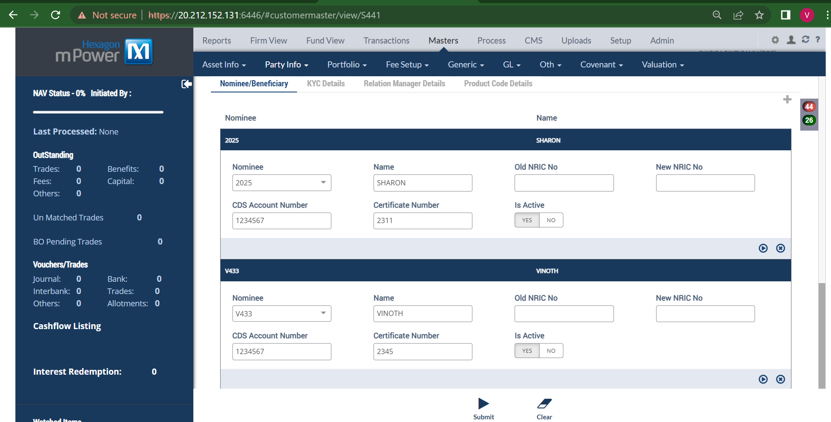

7d.Old NRIC No. and New NRIC No. field is not updating in Customer Nominee after approved by checker. (Company : CUSTODY TEST)


7e. Customer Nominee Excel file uploading successfully even though there is no existing Customer mentioned in the file. (Company : CUSTODY TEST)
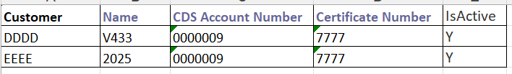
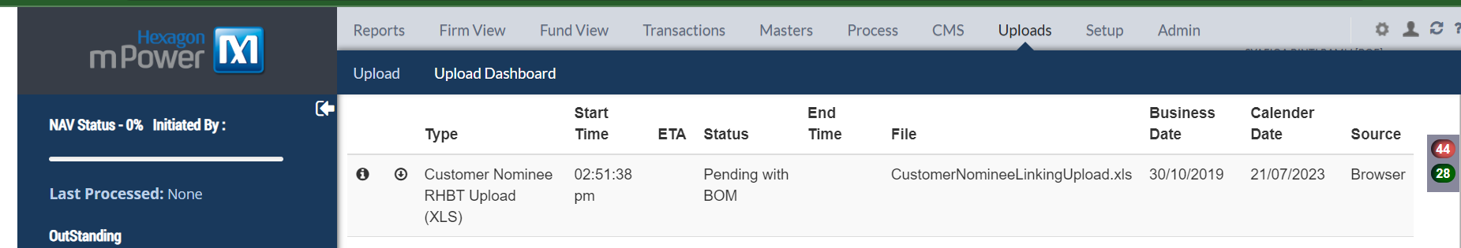
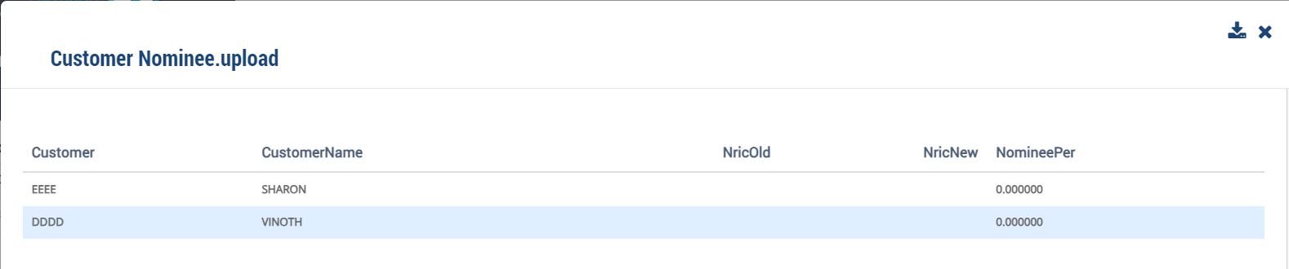

7f. When we overwrite the already existing Customer Nominee through Upload , Alert showing ‘Pending with 451934’(Maker ID). After approved from BOE, again it is throwing alert as Pending with BOE(Note: Need to show ‘Pending with BOMBOAMBOMM’) (Company : CUSTODY TEST)
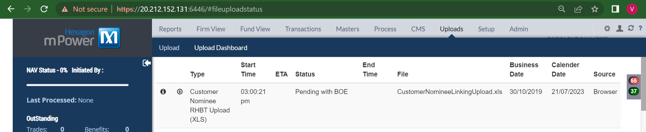

8.Portfolio Party Mapping (Customer + Beneficiary):
8a. Able to Submit the Portfolio Party Mapping Form with Share% and Nominal Held with Negative Values even though it is giving validation as ‘Minimum:0’(Company : CUSTODY TEST)
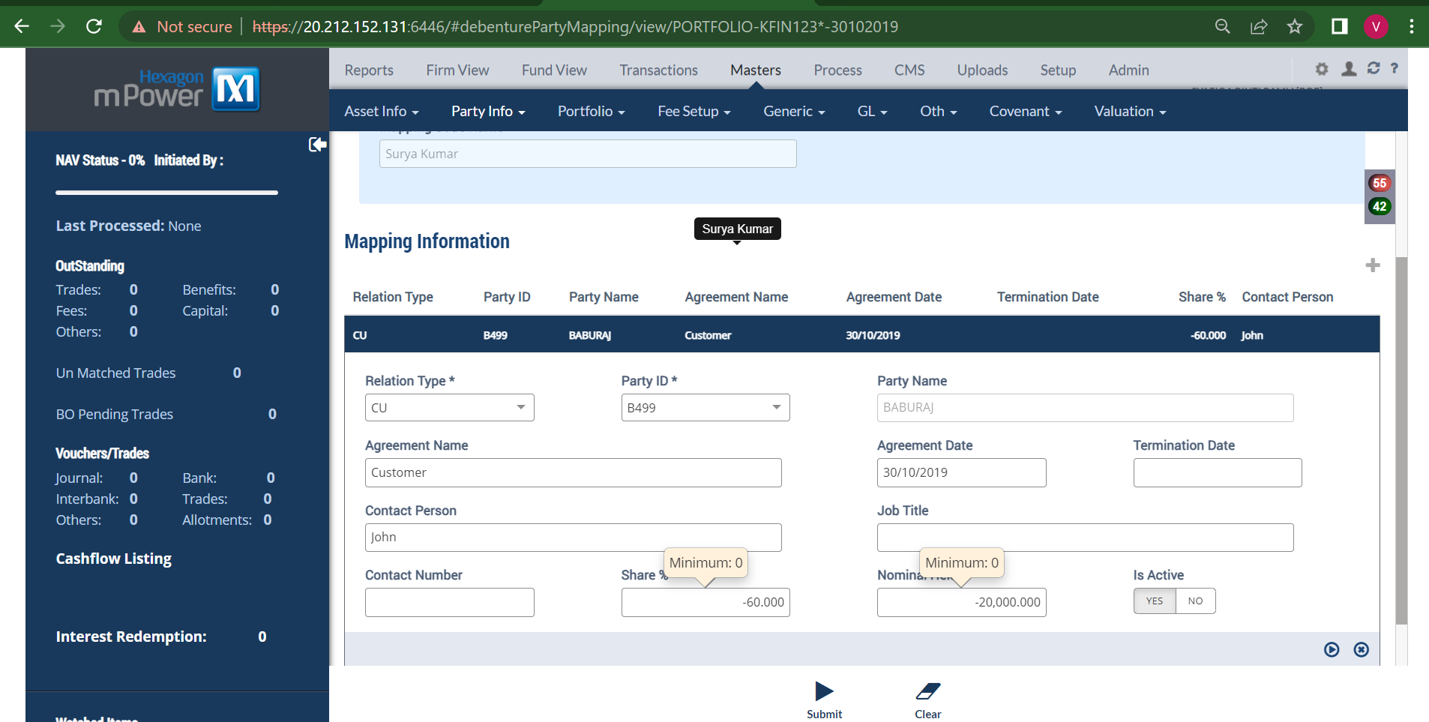
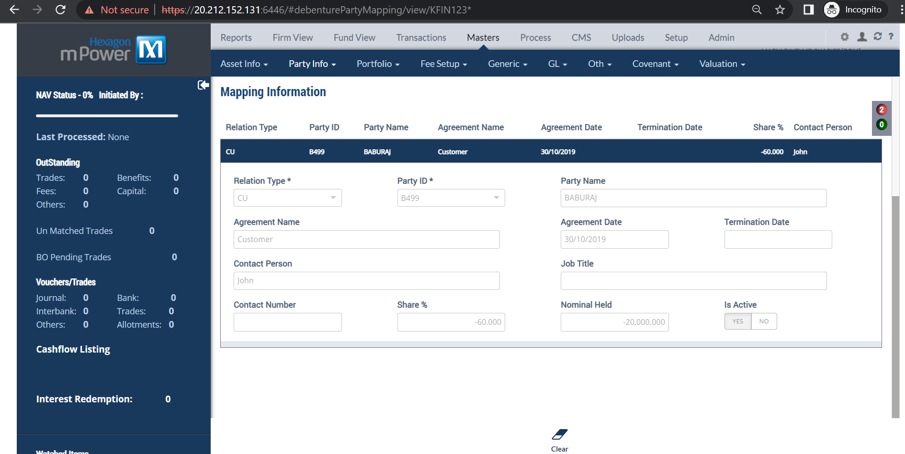

- Beneficiary Holdings:
9a) Bene Holdings is getting created Even though there is no Existing Beneficiary in Other Party master Screen.
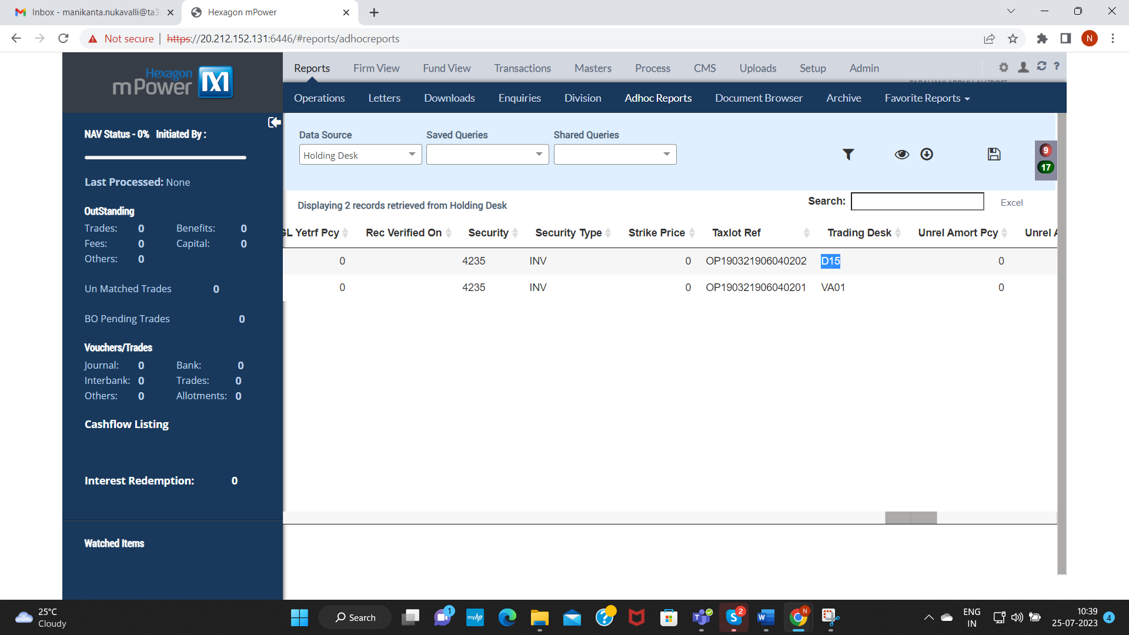

- Portfolio Holdings:
10a) In Portfolio Holding upload File, giving negative QTY and Price it is uploading successfully, but it showing error in Bene Holdings Upload as Cannot Enter Negative Values.

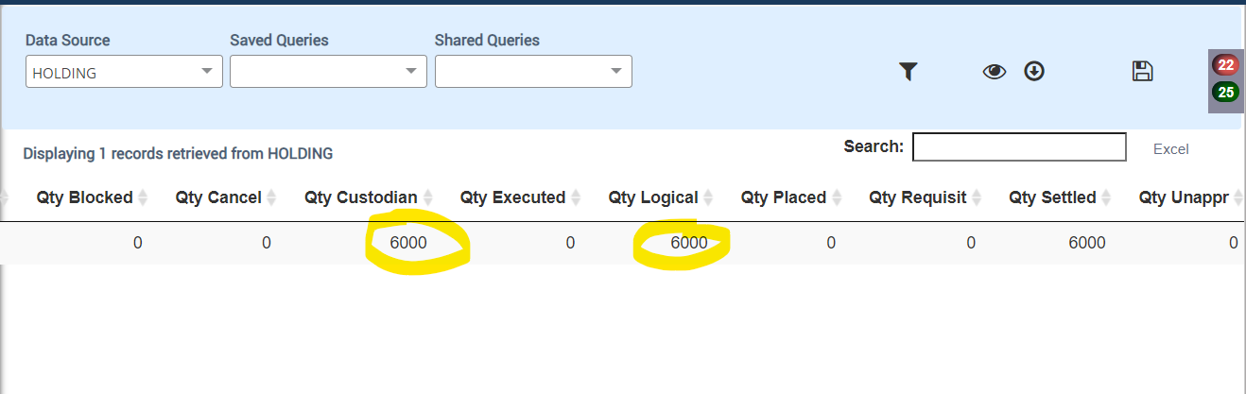

10b) Taking Other Company Details (CustodyTest) and Uploading in My Company(KFINTECH) and in Adhoc Reports it is not getting Posted.(But Uploading itself not Giving Any Error)

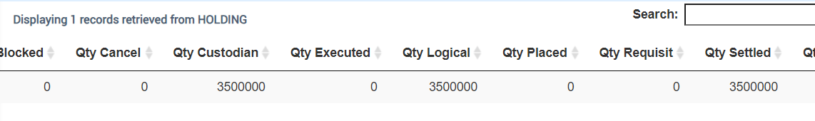

10c) Portfolio Holdings With Different Company and Portfolio, and GL Entry with Different Company and Portfolio it is Uploading Portfolio Holdings Successfully.
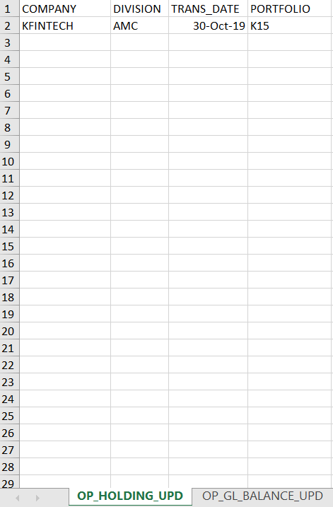
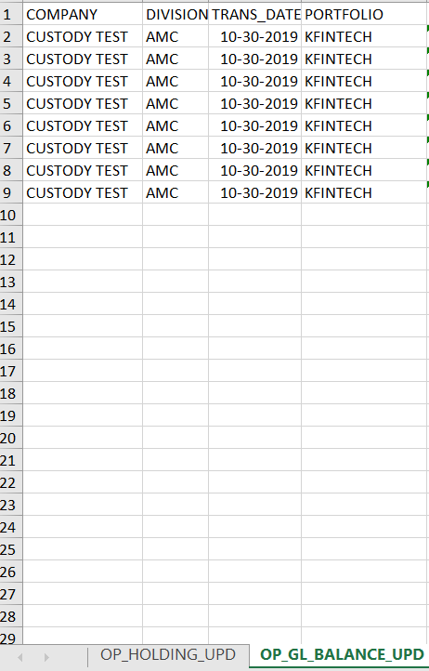

- Bene Upload:
11a) DOB Capturing Wrongly
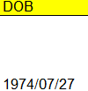
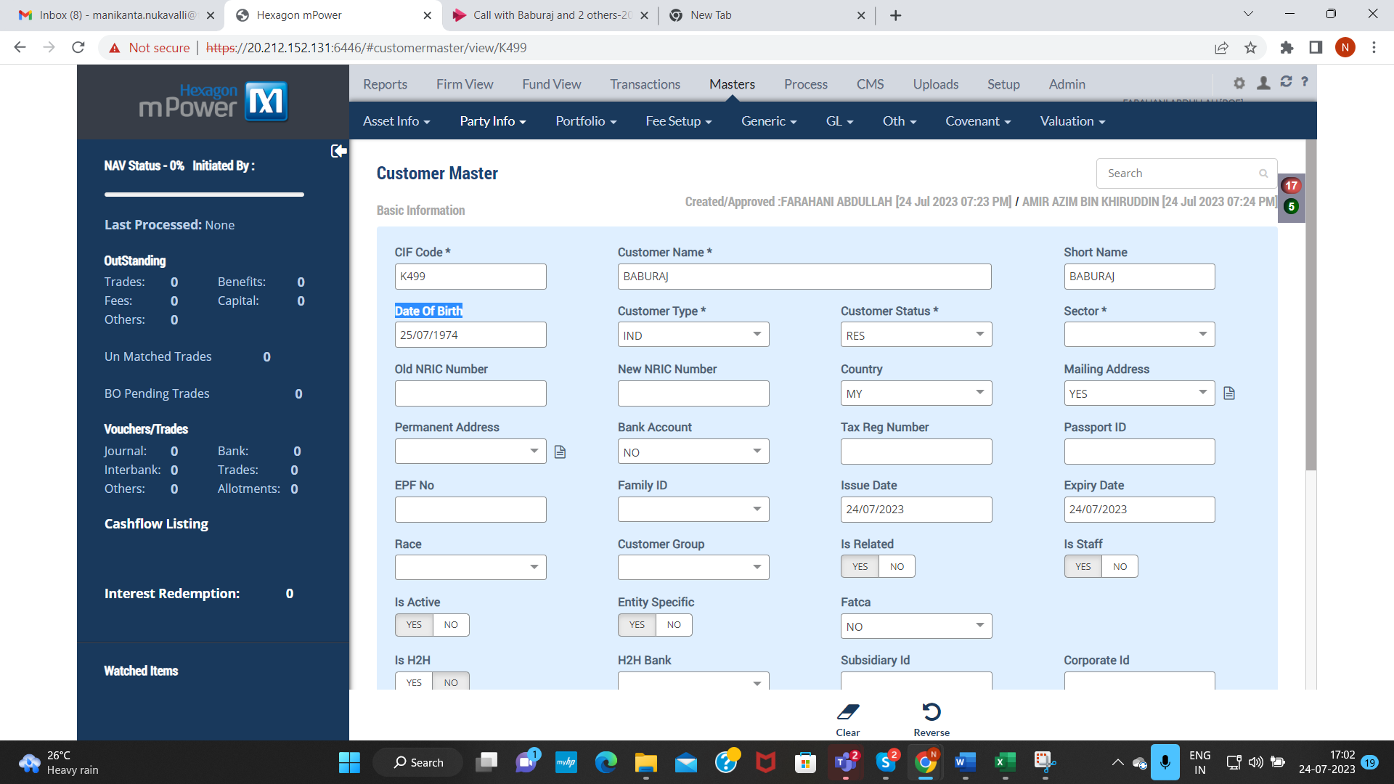

- Misc Payment Screen:
12a) We are Getting this Validation while submitting Misc Payment Form.(Kindly Rectify Immediately)
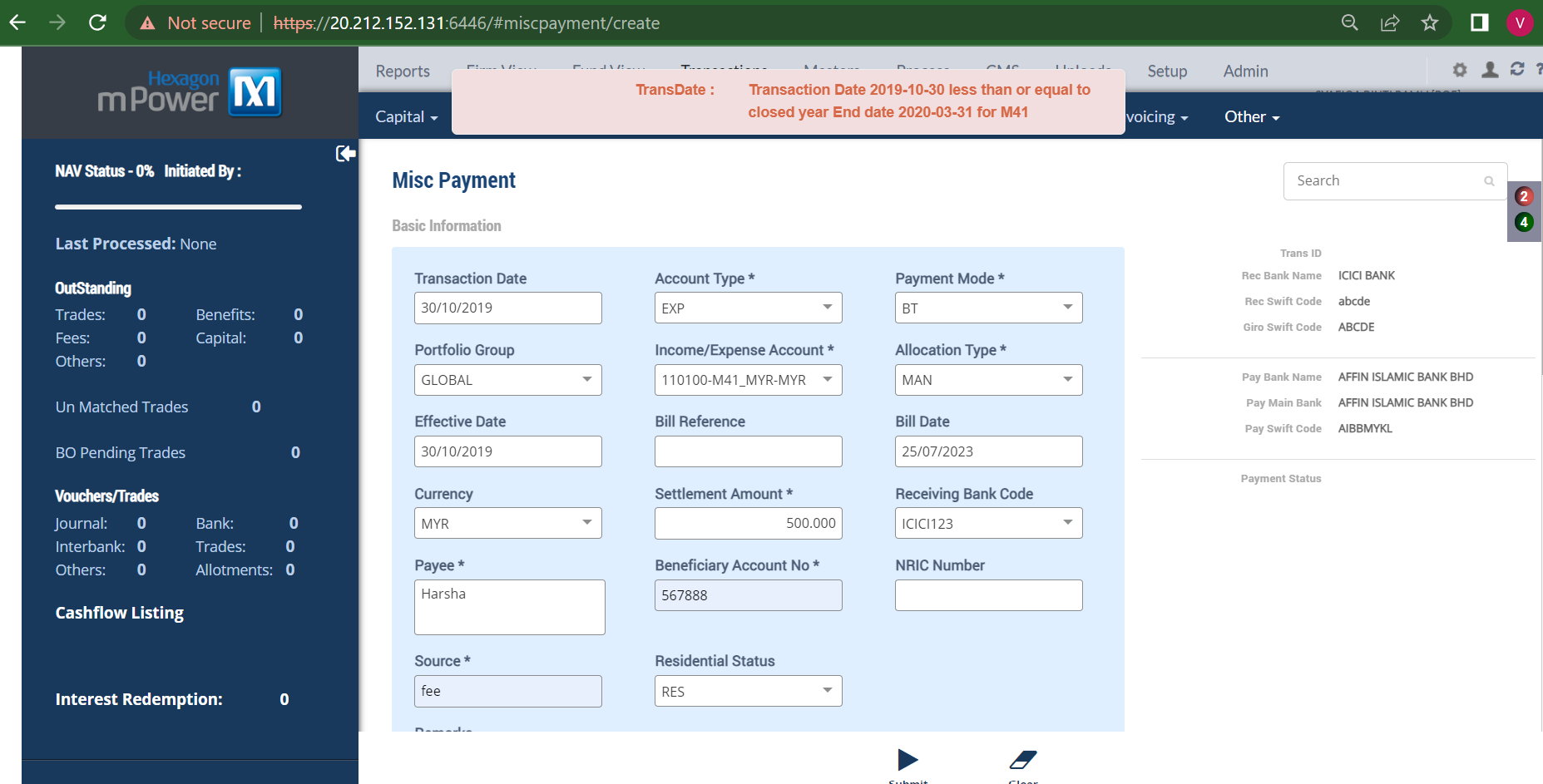

- Customer Master Screen:
13a) Giving same certificate number for different nominees getting validation error.
